**Project Design Phase-II**

**Technology Stack (Architecture & Stack)**

|  |  |
| --- | --- |
| Date | 14 October 2022 |
| Team ID | PNT2022TMID09881 |
| Project Name | AI FOR A NOVEL METHOD FOR HANDWRITTEN DIGIT RECOGNITION SYSTEM |
| Maximum Marks | 4 Marks |

**Technical Architecture:**

The architectural diagram of the model is as below and the Technology used is shown in table1 & table 2

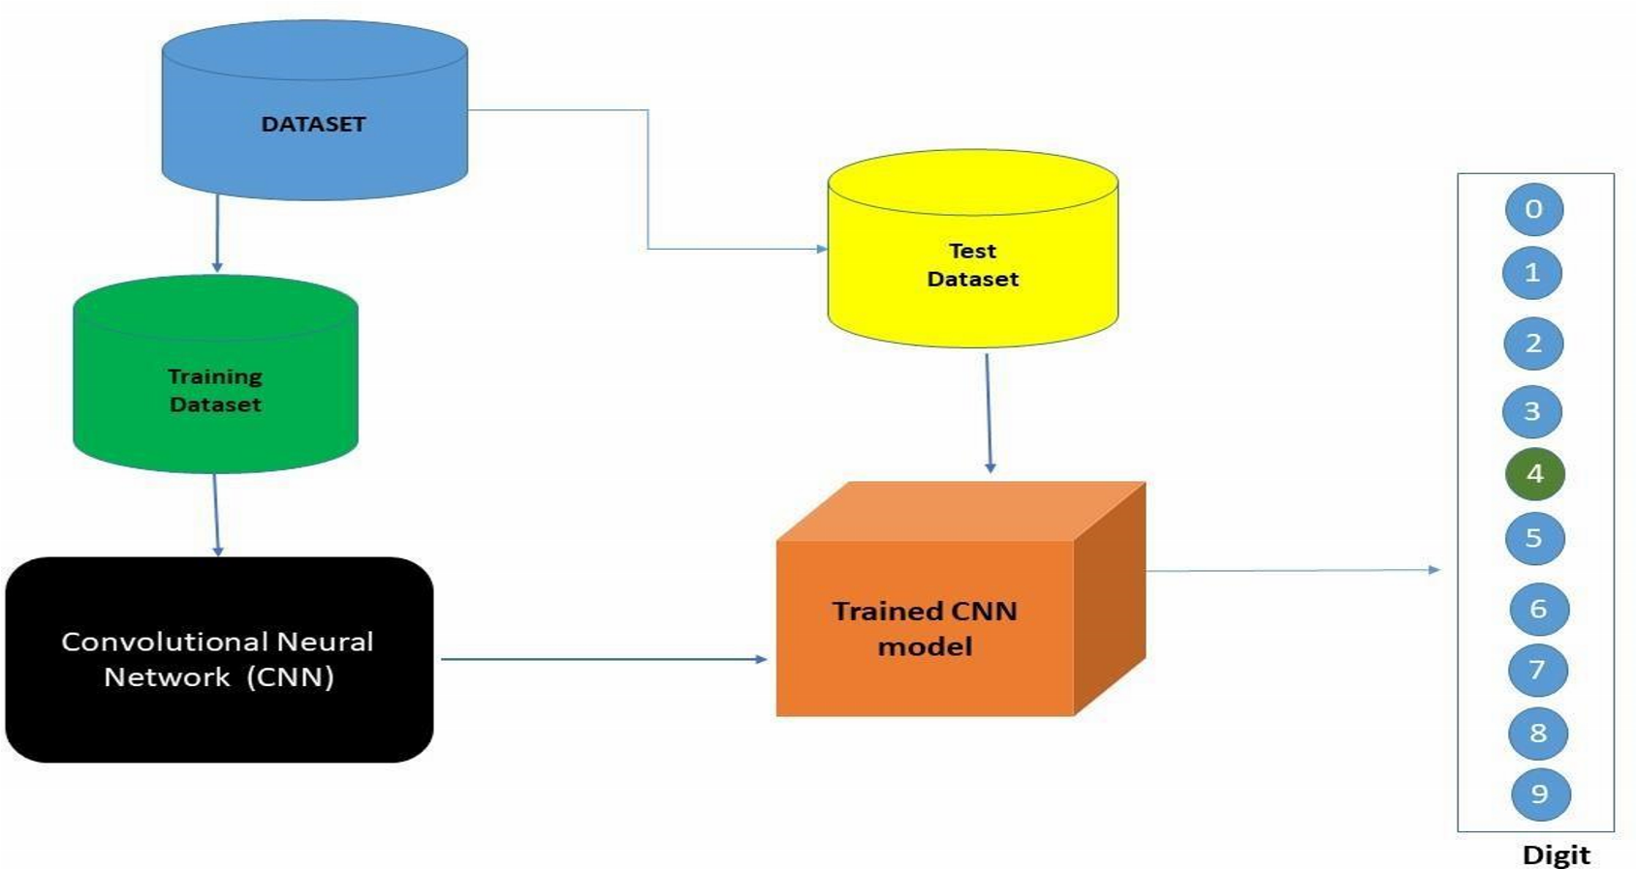

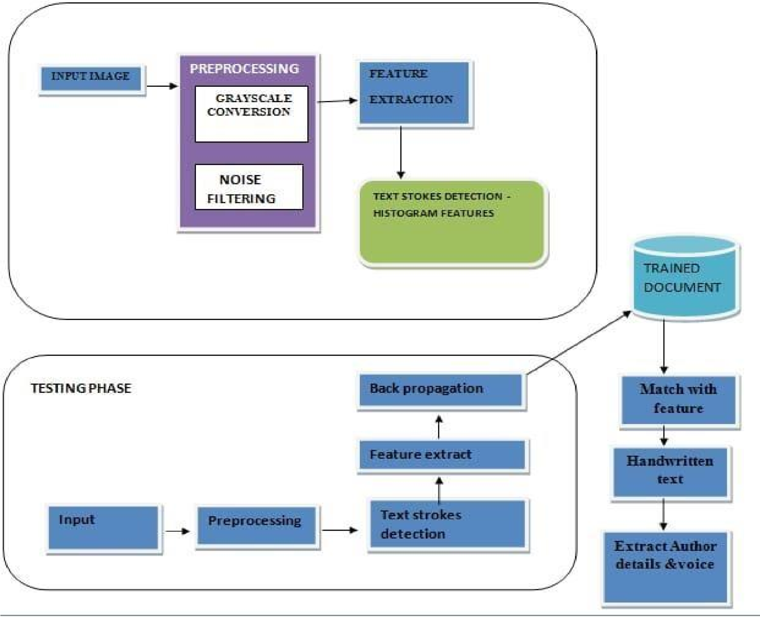

**FIG. 1. BLOCK DIAGRAM**

**Table-1: Components & Technologies:**

|  |  |  |  |
| --- | --- | --- | --- |
| **S.No** | **Component** | **Description** | **Technology** |
| 1. | User Interface | How user interacts with application e.g., Mobile Application | HTML, CSS, JavaScript / Angular JS / Node Red. |
| 2. | Application Logic-1 | Logic for a process in the application | Java / Python |
| 3. | Application Logic-2 | Logic for a process in the application | IBM Watson STT service |
| 4. | Application Logic-3 | Logic for a process in the application | IBM Watson Assistant |
| 5. | Database | Data Type, Configurations etc. | MySQL, NoSQL, etc. |
| 6. | Cloud Database | Database Service on AI | IBM DB2. |
| 7. | File Storage | File storage requirements | IBM Block Storage or Other Storage Service or Local Filesystem |
| 8. | External API-1 | Purpose of External API used in the application | IBM Weather API, etc. |
| 9. | IoT Model | Purpose of AI Model is for integrating the sensors with a user interface. | IBM AI Platform |
| 10. | Infrastructure (Server / AI) | Application Deployment on Local System / AI Local Server  Configuration  AI Server Configuration | Local, Kubernetes, etc. |

**Table-2: Application Characteristics:**

|  |  |  |  |
| --- | --- | --- | --- |
| **S.No** | **Characteristics** | **Description** | **Technology** |
| 1. | Open-Source Frameworks | List the open-source frameworks used | Technology of Opensource framework |
| 2. | Security Implementations | List all the security / access controls implemented, use of firewalls etc. | SHA-256, Encryptions, IAM Controls,  OWASP |
| 3. | Scalable Architecture | Justify the scalability of architecture | 3 – tier, Micro-services |
| 4. | Availability | Abstract and Figures. The features for handwritten digit recognition have been introduced. These features are based on shape analysis of the digit image and extract slant or slope information. They are effective in obtaining good recognition accuracies | Distributed servers, IBM cloud |
| 5. | Performance | The standard implementations of neural networks achieve an accuracy of ~ (98–99) percent in correctly classifying the handwritten digits. | Number of requests per sec, use of Cache, use of CDN’s |